**EXPERIMENT NO - 02**

**● AIM:**

Experiment based on React Hooks (useEffect, useContext, custom hooks) **● THEORY:**

**Introduction to React Hooks**

React Hooks are functions that enable functional components to manage state, side effects, and other React features traditionally handled by class components. Introduced in React 16.8, they provide a more concise and reusable approach to building components. The key hooks used in this application—useEffect, useContext, and custom hooks—form the backbone of its interactivity and state management, aligning with modern React development practices.

● **useEffect**: This hook manages side effects in functional components, such as data fetching, subscriptions, or manual DOM updates. It runs after every render by default and can be configured to run conditionally based on dependencies, mimicking lifecycle methods like componentDidMount and componentDidUpdate.

● **useContext**: Allows components to access context (global state) without prop drilling, providing a way to share data (e.g., theme or car state) across the component tree efficiently.

● **Custom Hooks**: These are user-defined hooks that encapsulate reusable logic, combining built-in hooks (e.g., useState, useEffect) to abstract complex functionality into manageable units.

**How These Hooks Are Used in the Car Virtual Showroom**

**1. useEffect: Managing Side Effects and Data Flow**

● **Purpose**: useEffect is employed to handle asynchronous operations and side effects, ensuring the application remains responsive and data-driven. ● **Implementation**:

○ **Data Fetching**: Used to fetch car data from a simulated API (e.g., a mock endpoint or Open Library API as a proxy), with useEffect triggering the fetch on component mount and updating the UI with the response.

**2. useContext: Global State Management**

● **Purpose**: useContext provides a centralized mechanism to manage global state, avoiding prop drilling and enabling seamless theme and car state propagation.

● **Implementation**:

○ **CarProvider**: Wraps the application in App.tsx, creating a CarContext that holds state like selected cars, filters, and favorites.

**3. Custom Hooks: Reusable Logic Encapsulation**

● **Purpose**: Custom hooks abstract repetitive or complex logic into reusable functions, enhancing modularity and adhering to the component-based architecture.

● **Implementation**:

○ **useCarData**: Fetches and caches car data, integrating useEffect for API calls and useState for state management.

*WHAT'S MORE INCLUDED:*

**1. Tailwind CSS, CSS Grid/Flexbox, Transitions/Animations**: Drives the responsive, animated design (e.g., hover-lift, glass effects).

**2. Event Handling**: Implements onClick, onChange, and onMouseEnter with proper propagation control, driving interactive features like car selection and hover effects.

**3. useReducer Hook**: Complements useContext in CarContext for complex state management, handling actions like ADD_TO_FAVORITES or SET_FILTERS with a reducer function, ensuring predictable state transitions.

**4. useState Hook**: Manages local component state (e.g., selected colors, active tabs) within CarShowroom, providing fine-grained control over UI elements like virtual tour views.

**● SOURCE CODE:**

**index.css:**

**@tailwind components;**

**@tailwind utilities;**

**@layer base {**

**body {**

**font-family: 'Inter', -apple-system, BlinkMacSystemFont, 'Segoe UI', sans-serif;**

**}**

**}**

**@layer utilities {**

**.slider::-webkit-slider-thumb { appearance: none;**

**height: 20px;**

**width: 20px;**

**border-radius: 50%;**

**background: #3B82F6;**

**cursor: pointer;**

**border: 2px solid #1F2937; box-shadow: 0 0 0 1px #374151; }**

**.slider::-moz-range-thumb { height: 20px;**

**width: 20px;**

**border-radius: 50%;**

**background: #3B82F6;**

**cursor: pointer;**

**border: 2px solid #1F2937; box-shadow: 0 0 0 1px #374151; }**

**/* Custom scrollbar */**

**::-webkit-scrollbar {**

**width: 6px;**

**}**

**::-webkit-scrollbar-track { background: #1F2937;**

**}**

**::-webkit-scrollbar-thumb { background: #4B5563;**

**border-radius: 3px;**

**}**

**::-webkit-scrollbar-thumb:hover { background: #6B7280;**

**}**

**/* Glass morphism effect */ .glass {**

**backdrop-filter: blur(16px);**

**-webkit-backdrop-filter: blur(16px);**

**background: rgba(17, 24, 39, 0.7);**

**border: 1px solid rgba(75, 85, 99, 0.3); }**

**/* Gradient text */**

**.gradient-text {**

**background: linear-gradient(135deg, #3B82F6, #8B5CF6); -webkit-background-clip: text;**

**-webkit-text-fill-color: transparent;**

**background-clip: text;**

**}**

**/* Hover animations */**

**.hover-lift {**

**transition: all 0.3s cubic-bezier(0.4, 0, 0.2, 1); }**

**.hover-lift:hover {**

**transform: translateY(-8px);**

**box-shadow: 0 20px 40px rgba(0, 0, 0, 0.3); }**

**/* Loading shimmer */**

**.shimmer {**

**background: linear-gradient(90deg,**

**rgba(255, 255, 255, 0) 0%,**

**rgba(255, 255, 255, 0.1) 50%,**

**rgba(255, 255, 255, 0) 100%);**

**background-size: 200% 100%;**

**animation: shimmer 2s infinite;**

**}**

**@keyframes shimmer {**

**0% { background-position: -200% 0; }**

**100% { background-position: 200% 0; }**

**}**

**}**

**CarCard.tsx**

**import React from 'react';**

**import { Heart, Eye, Plus, Zap, Gauge, Fuel } from 'lucide-react'; import { Car } from '../types/car';**

**import { useFavorites } from '../hooks/useFavorites';**

**import { useComparison } from '../hooks/useComparison';**

**import { useCarContext } from '../contexts/CarContext';**

**interface CarCardProps {**

**car: Car;**

**}**

**const CarCard: React.FC<CarCardProps> = ({ car }) => {**

**const { dispatch } = useCarContext();**

**const { isFavorite, addToFavorites, removeFromFavorites } = useFavorites();**

**const { addToComparison, isInComparison, canAddMore } = useComparison();**

**const handleFavoriteClick = (e: React.MouseEvent) => { e.stopPropagation();**

**if (isFavorite(car.id)) {**

**removeFromFavorites(car.id);**

**} else {**

**addToFavorites(car.id);**

**}**

**};**

**const handleCompareClick = (e: React.MouseEvent) => {**

**e.stopPropagation();**

**if (!isInComparison(car.id) && canAddMore) {**

**addToComparison(car);**

**}**

**};**

**const handleViewDetails = () => {**

**dispatch({ type: 'SET_SELECTED_CAR', payload: car }); };**

**const formatPrice = (price: number) => {**

**return new Intl.NumberFormat('en-US', {**

**style: 'currency',**

**currency: 'USD',**

**minimumFractionDigits: 0**

**}).format(price);**

**};**

**return (**

**<div className="group bg-gradient-to-br from-gray-900/90 to-gray-800/90 backdrop-blur-sm border border-gray-700/50 rounded-2xl overflow-hidden hover:border-blue-500/50 transition-all duration-500 hover:transform hover:scale-105">**

**<div className="relative overflow-hidden">**

**<img**

**src={car.images.main}**

**alt={`${car.brand} ${car.model}`}**

**className="w-full h-64 object-cover transition-transform duration-700 group-hover:scale-110"**

**/>**

**<div className="absolute inset-0 bg-gradient-to-t from-black/50 to-transparent opacity-0 group-hover:opacity-100 transition-opacity duration-300" />**

**{/* Action Buttons */}**

**<div className="absolute top-4 right-4 flex gap-2"> <button**

**onClick={handleFavoriteClick}**

**className={`p-2 rounded-full backdrop-blur-sm transition-all duration-200 ${**

**isFavorite(car.id)**

**? 'bg-red-500 text-white'**

**: 'bg-black/30 text-white hover:bg-red-500' }`}**

**>**

**<Heart className={`w-4 h-4 ${isFavorite(car.id) ? 'fill-current' : ''}`} />**

**</button>**

**{canAddMore && !isInComparison(car.id) && (**

**<button**

**onClick={handleCompareClick}**

**className="p-2 rounded-full bg-black/30 text-white hover:bg-blue-500 backdrop-blur-sm transition-all duration-200" >**

**<Plus className="w-4 h-4" />**

**</button>**

**)}**

**</div>**

**{/* Fuel Type Badge */}**

**<div className="absolute top-4 left-4">**

**<div className={`px-3 py-1 rounded-full text-xs font-medium backdrop-blur-sm ${**

**car.fuelType === 'electric'**

**? 'bg-green-500/20 text-green-300 border border-green-500/30'**

**: car.fuelType === 'hybrid'**

**? 'bg-yellow-500/20 text-yellow-300 border border-yellow-500/30'**

**: 'bg-gray-500/20 text-gray-300 border border-gray-500/30' }`}>**

**{car.fuelType === 'electric' ? '**⚡ **Electric' : car.fuelType === 'hybrid' ? '**�� **Hybrid' : '**⛽ **Gasoline'} </div>**

**</div>**

**</div>**

**<div className="p-6">**

**<div className="flex justify-between items-start mb-3"> <div>**

**<h3 className="text-xl font-bold text-white mb-1"> {car.brand} {car.model}**

**</h3>**

**<p className="text-gray-400 text-sm">{car.year} • {car.type}</p>**

**</div>**

**<div className="text-right">**

**<p className="text-2xl font-bold text-blue-400">{formatPrice(car.price)}</p>**

**</div>**

**</div>**

**{/* Performance Stats */}**

**<div className="grid grid-cols-3 gap-4 mb-4">**

**<div className="text-center">**

**<div className="flex items-center justify-center mb-1">**

**<Zap className="w-4 h-4 text-yellow-400" /> </div>**

**<p className="text-sm font-medium text-white">{car.horsepower}</p>**

**<p className="text-xs text-gray-400">HP</p>**

**</div>**

**<div className="text-center">**

**<div className="flex items-center justify-center mb-1"> <Gauge className="w-4 h-4 text-red-400" /> </div>**

**<p className="text-sm font-medium text-white">{car.acceleration}</p>**

**<p className="text-xs text-gray-400">0-60</p> </div>**

**<div className="text-center">**

**<div className="flex items-center justify-center mb-1"> <Fuel className="w-4 h-4 text-blue-400" /> </div>**

**<p className="text-sm font-medium text-white">{car.topSpeed}</p>**

**<p className="text-xs text-gray-400">km/h</p> </div>**

**</div>**

**{/* Rating */}**

**<div className="flex items-center justify-between mb-4"> <div className="flex items-center gap-1">**

**{[...Array(5)].map((_, i) => (**

**<div**

**key={i}**

**className={`w-4 h-4 rounded-full ${**

**i < Math.floor(car.rating) ? 'bg-yellow-400' : 'bg-gray-600'**

**}`}**

**/>**

**))}**

**<span className="text-sm text-gray-400 ml-2"> {car.rating} ({car.reviews} reviews)**

**</span>**

**</div>**

**</div>**

**{/* View Details Button */}**

**<button**

**onClick={handleViewDetails}**

**className="w-full flex items-center justify-center gap-2 px-6 py-3 bg-gradient-to-r from-blue-600 to-purple-600 text-white font-medium rounded-xl hover:from-blue-700 hover:to-purple-700 transform transition-all duration-200 hover:scale-105"**

**>**

**<Eye className="w-4 h-4" />**

**View Details**

**</button>**

**</div>**

**</div>**

**);**

**};**

**export default CarCard;**

**carShowroom.tsx**

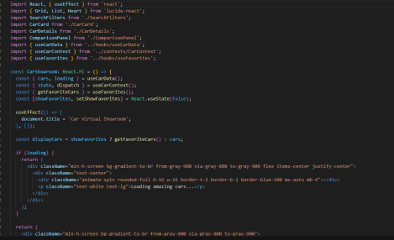

**SearchFilters.tsx**

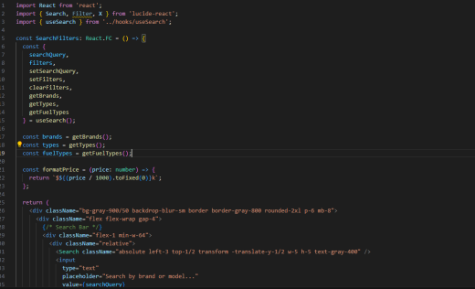**CarDetails.tsx**

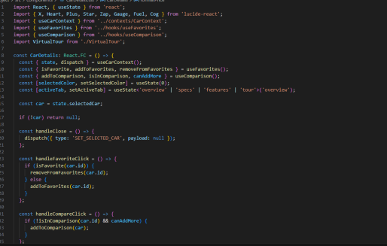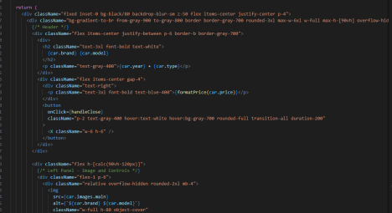**cars.ts**

**import { Car } from '../types/car';**

**export const carsData: Car[] = [**

**{**

**id: '1',**

**brand: 'Tesla',**

**model: 'Model S',**

**year: 2024,**

**price: 89990,**

**type: 'sedan',**

**fuelType: 'electric',**

**transmission: 'automatic',**

**engine: 'Electric Motor',**

**horsepower: 670,**

**topSpeed: 200,**

**acceleration: '3.1s 0-60mph',**

**colors: ['Pearl White', 'Solid Black', 'Midnight Silver', 'Deep Blue', 'Pearl Red'],**

**features: [**

**'Autopilot',**

**'17" Touchscreen',**

**'Premium Audio',**

**'Glass Roof',**

**'Heated Seats',**

**'Supercharging'**

**],**

**images: {**

**main: 'https://images.pexels.com/photos/3802510/pexels-photo-3802510.jpeg?auto=c ompress&cs=tinysrgb&w=800',**

**gallery: [**

**'https://images.pexels.com/photos/3802510/pexels-photo-3802510.jpeg?auto=c ompress&cs=tinysrgb&w=800',**

**'https://images.pexels.com/photos/3874337/pexels-photo-3874337.jpeg?auto=c ompress&cs=tinysrgb&w=800'**

**]**

**},**

**description: 'The pinnacle of electric luxury with unmatched performance and technology.',**

**rating: 4.8,**

**reviews: 1247**

**},**

**{**

**id: '2',**

**brand: 'Porsche',**

**model: '911 Turbo',**

**year: 2024,**

**price: 174300,**

**type: 'coupe',**

**fuelType: 'gasoline',**

**transmission: 'automatic',**

**engine: '3.8L Twin-Turbo H6',**

**horsepower: 572,**

**topSpeed: 320,**

**acceleration: '2.7s 0-60mph',**

**colors: ['Racing Yellow', 'Jet Black', 'Guards Red', 'Carrara White', 'Miami Blue'],**

**features: [**

**'Sport Chrono Package',**

**'PASM Suspension',**

**'Sport Exhaust',**

**'Carbon Fiber Interior',**

**'Ceramic Brakes',**

**'Launch Control'**

**],**

**images: {**

**main: 'https://images.pexels.com/photos/3752169/pexels-photo-3752169.jpeg?auto=c ompress&cs=tinysrgb&w=800',**

**gallery: [**

**'https://images.pexels.com/photos/3752169/pexels-photo-3752169.jpeg?auto=c ompress&cs=tinysrgb&w=800',**

**'https://images.pexels.com/photos/1545743/pexels-photo-1545743.jpeg?auto=c ompress&cs=tinysrgb&w=800'**

**]**

**},**

**description: 'Legendary sports car engineering with modern performance technology.',**

**rating: 4.9,**

**reviews: 892**

**},**

**{**

**id: '3',**

**brand: 'BMW',**

**model: 'X5 M',**

**year: 2024,**

**price: 108900,**

**type: 'suv',**

**fuelType: 'gasoline',**

**transmission: 'automatic',**

**engine: '4.4L Twin-Turbo V8',**

**horsepower: 617,**

**topSpeed: 290,**

**acceleration: '3.8s 0-60mph',**

**colors: ['Alpine White', 'Jet Black', 'Storm Bay', 'Mineral Grey', 'Phytonic Blue'],**

**features: [**

**'M Performance Package',**

**'Adaptive M Suspension',**

**'Harman Kardon Audio',**

**'Panoramic Roof',**

**'Gesture Control',**

**'Wireless Charging'**

**],**

**images: {**

**main: 'https://images.pexels.com/photos/3729464/pexels-photo-3729464.jpeg?auto=c ompress&cs=tinysrgb&w=800',**

**gallery: [**

**'https://images.pexels.com/photos/3729464/pexels-photo-3729464.jpeg?auto=c ompress&cs=tinysrgb&w=800',**

**'https://images.pexels.com/photos/1007410/pexels-photo-1007410.jpeg?auto=c ompress&cs=tinysrgb&w=800'**

**]**

**},**

**description: 'High-performance luxury SUV that combines sportiness with versatility.',**

**rating: 4.7,**

**reviews: 634**

**},**

**{**

**id: '4',**

**brand: 'Audi',**

**model: 'RS6 Avant',**

**year: 2024,**

**price: 116500,**

**type: 'sedan',**

**fuelType: 'gasoline',**

**transmission: 'automatic',**

**engine: '4.0L Twin-Turbo V8',**

**horsepower: 591,**

**topSpeed: 280,**

**acceleration: '3.6s 0-60mph',**

**colors: ['Nardo Grey', 'Mythos Black', 'Glacier White', 'Daytona Grey', 'Sebring Black'],**

**features: [**

**'Quattro AWD',**

**'RS Sport Suspension',**

**'Bang & Olufsen Audio',**

**'Matrix LED Headlights',**

**'Virtual Cockpit Plus',**

**'Sport Differential'**

**],**

**images: {**

**main: 'https://images.pexels.com/photos/3729465/pexels-photo-3729465.jpeg?auto=c ompress&cs=tinysrgb&w=800',**

**gallery: [**

**'https://images.pexels.com/photos/3729465/pexels-photo-3729465.jpeg?auto=c ompress&cs=tinysrgb&w=800',**

**'https://images.pexels.com/photos/909907/pexels-photo-909907.jpeg?auto=com press&cs=tinysrgb&w=800'**

**]**

**},**

**description: 'The ultimate performance wagon that redefines practical luxury.',**

**rating: 4.6,**

**reviews: 445**

**},**

**{**

**id: '5',**

**brand: 'Mercedes',**

**model: 'AMG GT',**

**year: 2024,**

**price: 138000,**

**type: 'coupe',**

**fuelType: 'gasoline',**

**transmission: 'automatic',**

**engine: '4.0L Biturbo V8',**

**horsepower: 523,**

**topSpeed: 310,**

**acceleration: '3.7s 0-60mph',**

**colors: ['AMG Solarbeam', 'Obsidian Black', 'Iridium Silver', 'Jupiter Red', 'Designo Diamond White'],**

**features: [**

**'AMG Performance Package',**

**'Active Aerodynamics',**

**'Burmester Audio',**

**'AMG Track Pace',**

**'Dynamic Select',**

**'Performance Seats'**

**],**

**images: {**

**main: 'https://images.pexels.com/photos/3785935/pexels-photo-3785935.jpeg?auto=c ompress&cs=tinysrgb&w=800',**

**gallery: [**

**'https://images.pexels.com/photos/3785935/pexels-photo-3785935.jpeg?auto=c ompress&cs=tinysrgb&w=800',**

**'https://images.pexels.com/photos/1719648/pexels-photo-1719648.jpeg?auto=c ompress&cs=tinysrgb&w=800'**

**]**

**},**

**description: 'Pure driving emotion in the form of a high-performance sports car.',**

**rating: 4.8,**

**reviews: 723**

**},**

**{**

**id: '6',**

**brand: 'Lamborghini',**

**model: 'Huracán',**

**year: 2024,**

**price: 248295,**

**type: 'coupe',**

**fuelType: 'gasoline',**

**transmission: 'automatic',**

**engine: '5.2L V10',**

**horsepower: 631,**

**topSpeed: 325,**

**acceleration: '2.9s 0-60mph',**

**colors: ['Arancio Borealis', 'Nero Nemesis', 'Bianco Icarus', 'Verde Mantis', 'Rosso Mars'],**

**features: [**

**'All-Wheel Drive',**

**'Carbon Fiber Package',**

**'Alcantara Interior',**

**'Performance Traction Control',**

**'Magnetic Suspension',**

**'Launch Control'**

**],**

**images: {**

**main: 'https://images.pexels.com/photos/3802508/pexels-photo-3802508.jpeg?auto=c ompress&cs=tinysrgb&w=800',**

**gallery: [**

**'https://images.pexels.com/photos/3802508/pexels-photo-3802508.jpeg?auto=c ompress&cs=tinysrgb&w=800',**

**'https://images.pexels.com/photos/1592384/pexels-photo-1592384.jpeg?auto=c ompress&cs=tinysrgb&w=800'**

**]**

**},**

**description: 'Italian supercar excellence with breathtaking performance and design.',**

**rating: 4.9,**

**reviews: 312**

**}**

**];**

**● OUTPUT:**

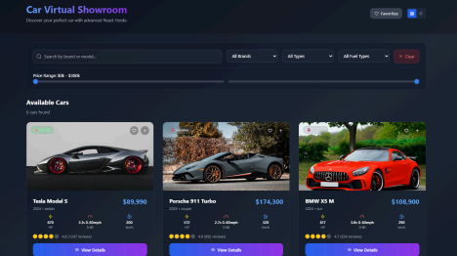

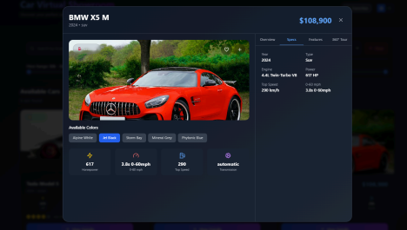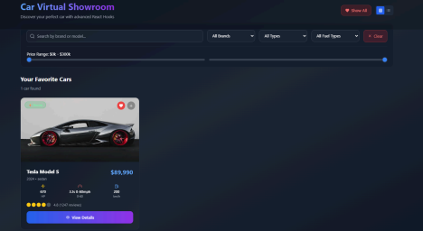

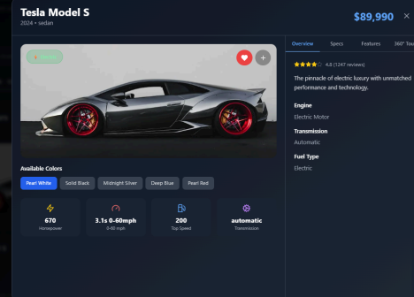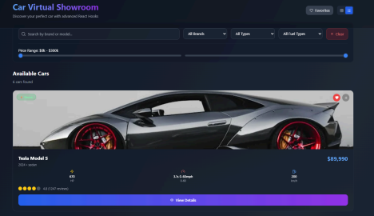

**● CONCLUSION:**

The experiment successfully demonstrates the power of React Hooks in building a dynamic and interactive Car Virtual Showroom. By leveraging useEffect for efficient side-effect management, useContext for streamlined global state access, and custom hooks for reusable logic, the application achieves modularity and scalability. The integration of useReducer and useState further enhances state management, ensuring predictable and responsive UI updates. Tailwind CSS, combined with animations and event handling, delivers a visually appealing and user-friendly interface. This approach highlights the effectiveness of Hooks in modern React development, enabling clean, maintainable, and performant code for complex applications.